|  |  |  |
| --- | --- | --- |
| Year 12 Physics – Lab Validation Assessment  Current Balance – The Motor Effect | | |
|  | | |
| **Name:** | **Teacher:** | **Score /20** |
| **Comment:** | | |



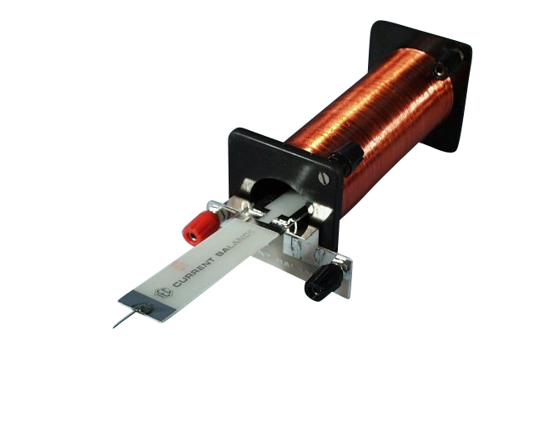

A pair of students are planning an investigation to accurately determine the flux density that exists in the single solenoid when running at 5A.

They know that a good investigation should use a series of measurements, so they vary the mass of nichrome wire at the end of the balance and then measure the amount of current (through the balance loop) that is required to achieve equilibrium with the mass.

To vary the mass they cut the nichrome wire into 2cm lengths and added one another 2cm length after each measurement.

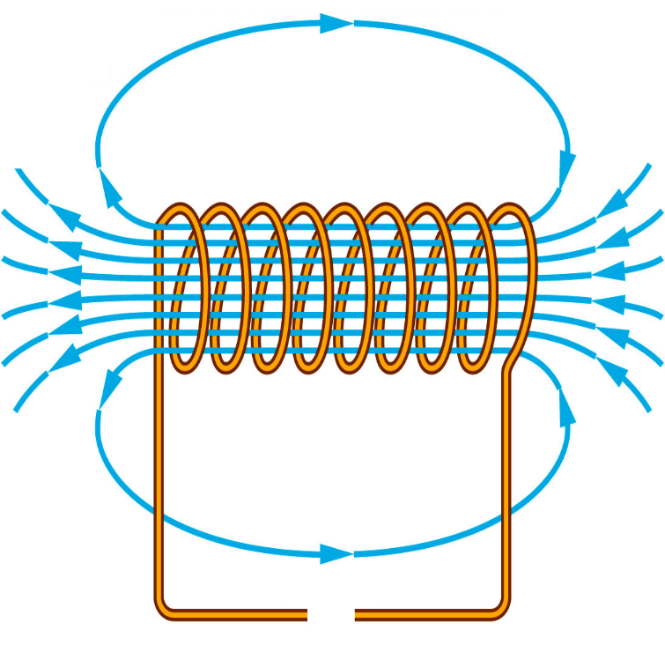

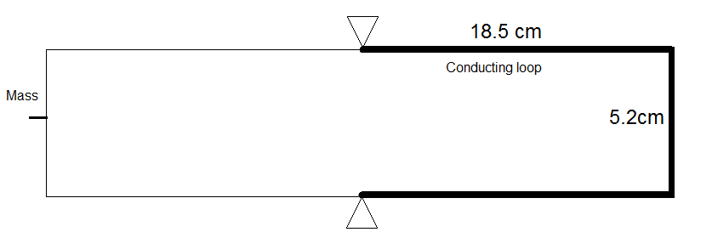***Diagrams -*** *Top down views of the conducting / balance loop and solenoid respectively are shown below. (just before the balance loop is moved to the right into the* solenoid.

Using the information presented in the BOTH diagrams:

1. Draw in the current direction required in the conducting loop to produce a force that could balance the mass at the other end.
2. Correctly draw in the current direction required in the solenoid circuit to produce the field shown.
3. Draw in an appropriate symbol for the DC power supply to match your current direction.

**[3 Marks]**

**Results**

|  |  |
| --- | --- |
| Mass of Nichrome Wire (1 metre length) | 1.75g |
| Length of Balance / Conductor | See diagram |

**Current in loop required to Balance the Mass. (Blank column provided for processing)**

|  |  |  |  |  |
| --- | --- | --- | --- | --- |
| **Number of 2 cm wire pieces** | **Current in Balance (A)** | **Current In Solenoid (A)** |  |  |
| 1 | 0.650 | 5.00 |  |  |
| 2 | 1.250 | 5.00 |  |  |
| 3 | 2.055 | 5.00 |  |  |
| 4 | 2.595 | 5.00 |  |  |
| 5 | 3.105 | 5.00 |  |  |
| 6 | 3.990 | 5.00 |  |  |
| 7 | 4.440 | 5.00 |  |  |
| 8 | 5.350 | 5.00 |  |  |

1. What was the Independent variable in this experiment? ____________________________
2. What was the Dependent Variable? __________________________________
3. Describe two variables that were controlled.

|  |
| --- |
|  |

**[4 Marks]**

1. Process the results to calculate mass and weight force.

**[2 Marks]**

1. On the next page, plot an appropriate graph that compares the comparing the balancing current required to the weight force added.

|  |  |  |  |  |  |  |  |  |  |  |  |  |  |  |  |  |  |  |  |  |  |  |  |  |  |  |  |  |  |  |  |  |  |  |  |  |  |
| --- | --- | --- | --- | --- | --- | --- | --- | --- | --- | --- | --- | --- | --- | --- | --- | --- | --- | --- | --- | --- | --- | --- | --- | --- | --- | --- | --- | --- | --- | --- | --- | --- | --- | --- | --- | --- | --- |
|  |  |  |  |  |  |  |  |  |  |  |  |  |  |  |  |  |  |  |  |  |  |  |  |  |  |  |  |  |  |  |  |  |  |  |  |  |  |
|  |  |  |  |  |  |  |  |  |  |  |  |  |  |  |  |  |  |  |  |  |  |  |  |  |  |  |  |  |  |  |  |  |  |  |  |  |  |
|  |  |  |  |  |  |  |  |  |  |  |  |  |  |  |  |  |  |  |  |  |  |  |  |  |  |  |  |  |  |  |  |  |  |  |  |  |  |
|  |  |  |  |  |  |  |  |  |  |  |  |  |  |  |  |  |  |  |  |  |  |  |  |  |  |  |  |  |  |  |  |  |  |  |  |  |  |
|  |  |  |  |  |  |  |  |  |  |  |  |  |  |  |  |  |  |  |  |  |  |  |  |  |  |  |  |  |  |  |  |  |  |  |  |  |  |
|  |  |  |  |  |  |  |  |  |  |  |  |  |  |  |  |  |  |  |  |  |  |  |  |  |  |  |  |  |  |  |  |  |  |  |  |  |  |
|  |  |  |  |  |  |  |  |  |  |  |  |  |  |  |  |  |  |  |  |  |  |  |  |  |  |  |  |  |  |  |  |  |  |  |  |  |  |
|  |  |  |  |  |  |  |  |  |  |  |  |  |  |  |  |  |  |  |  |  |  |  |  |  |  |  |  |  |  |  |  |  |  |  |  |  |  |
|  |  |  |  |  |  |  |  |  |  |  |  |  |  |  |  |  |  |  |  |  |  |  |  |  |  |  |  |  |  |  |  |  |  |  |  |  |  |
|  |  |  |  |  |  |  |  |  |  |  |  |  |  |  |  |  |  |  |  |  |  |  |  |  |  |  |  |  |  |  |  |  |  |  |  |  |  |
|  |  |  |  |  |  |  |  |  |  |  |  |  |  |  |  |  |  |  |  |  |  |  |  |  |  |  |  |  |  |  |  |  |  |  |  |  |  |
|  |  |  |  |  |  |  |  |  |  |  |  |  |  |  |  |  |  |  |  |  |  |  |  |  |  |  |  |  |  |  |  |  |  |  |  |  |  |
|  |  |  |  |  |  |  |  |  |  |  |  |  |  |  |  |  |  |  |  |  |  |  |  |  |  |  |  |  |  |  |  |  |  |  |  |  |  |
|  |  |  |  |  |  |  |  |  |  |  |  |  |  |  |  |  |  |  |  |  |  |  |  |  |  |  |  |  |  |  |  |  |  |  |  |  |  |
|  |  |  |  |  |  |  |  |  |  |  |  |  |  |  |  |  |  |  |  |  |  |  |  |  |  |  |  |  |  |  |  |  |  |  |  |  |  |
|  |  |  |  |  |  |  |  |  |  |  |  |  |  |  |  |  |  |  |  |  |  |  |  |  |  |  |  |  |  |  |  |  |  |  |  |  |  |
|  |  |  |  |  |  |  |  |  |  |  |  |  |  |  |  |  |  |  |  |  |  |  |  |  |  |  |  |  |  |  |  |  |  |  |  |  |  |
|  |  |  |  |  |  |  |  |  |  |  |  |  |  |  |  |  |  |  |  |  |  |  |  |  |  |  |  |  |  |  |  |  |  |  |  |  |  |
|  |  |  |  |  |  |  |  |  |  |  |  |  |  |  |  |  |  |  |  |  |  |  |  |  |  |  |  |  |  |  |  |  |  |  |  |  |  |
|  |  |  |  |  |  |  |  |  |  |  |  |  |  |  |  |  |  |  |  |  |  |  |  |  |  |  |  |  |  |  |  |  |  |  |  |  |  |
|  |  |  |  |  |  |  |  |  |  |  |  |  |  |  |  |  |  |  |  |  |  |  |  |  |  |  |  |  |  |  |  |  |  |  |  |  |  |
|  |  |  |  |  |  |  |  |  |  |  |  |  |  |  |  |  |  |  |  |  |  |  |  |  |  |  |  |  |  |  |  |  |  |  |  |  |  |
|  |  |  |  |  |  |  |  |  |  |  |  |  |  |  |  |  |  |  |  |  |  |  |  |  |  |  |  |  |  |  |  |  |  |  |  |  |  |
|  |  |  |  |  |  |  |  |  |  |  |  |  |  |  |  |  |  |  |  |  |  |  |  |  |  |  |  |  |  |  |  |  |  |  |  |  |  |
|  |  |  |  |  |  |  |  |  |  |  |  |  |  |  |  |  |  |  |  |  |  |  |  |  |  |  |  |  |  |  |  |  |  |  |  |  |  |
|  |  |  |  |  |  |  |  |  |  |  |  |  |  |  |  |  |  |  |  |  |  |  |  |  |  |  |  |  |  |  |  |  |  |  |  |  |  |
|  |  |  |  |  |  |  |  |  |  |  |  |  |  |  |  |  |  |  |  |  |  |  |  |  |  |  |  |  |  |  |  |  |  |  |  |  |  |
|  |  |  |  |  |  |  |  |  |  |  |  |  |  |  |  |  |  |  |  |  |  |  |  |  |  |  |  |  |  |  |  |  |  |  |  |  |  |
|  |  |  |  |  |  |  |  |  |  |  |  |  |  |  |  |  |  |  |  |  |  |  |  |  |  |  |  |  |  |  |  |  |  |  |  |  |  |
|  |  |  |  |  |  |  |  |  |  |  |  |  |  |  |  |  |  |  |  |  |  |  |  |  |  |  |  |  |  |  |  |  |  |  |  |  |  |
|  |  |  |  |  |  |  |  |  |  |  |  |  |  |  |  |  |  |  |  |  |  |  |  |  |  |  |  |  |  |  |  |  |  |  |  |  |  |
|  |  |  |  |  |  |  |  |  |  |  |  |  |  |  |  |  |  |  |  |  |  |  |  |  |  |  |  |  |  |  |  |  |  |  |  |  |  |
|  |  |  |  |  |  |  |  |  |  |  |  |  |  |  |  |  |  |  |  |  |  |  |  |  |  |  |  |  |  |  |  |  |  |  |  |  |  |
|  |  |  |  |  |  |  |  |  |  |  |  |  |  |  |  |  |  |  |  |  |  |  |  |  |  |  |  |  |  |  |  |  |  |  |  |  |  |
|  |  |  |  |  |  |  |  |  |  |  |  |  |  |  |  |  |  |  |  |  |  |  |  |  |  |  |  |  |  |  |  |  |  |  |  |  |  |
|  |  |  |  |  |  |  |  |  |  |  |  |  |  |  |  |  |  |  |  |  |  |  |  |  |  |  |  |  |  |  |  |  |  |  |  |  |  |
|  |  |  |  |  |  |  |  |  |  |  |  |  |  |  |  |  |  |  |  |  |  |  |  |  |  |  |  |  |  |  |  |  |  |  |  |  |  |
|  |  |  |  |  |  |  |  |  |  |  |  |  |  |  |  |  |  |  |  |  |  |  |  |  |  |  |  |  |  |  |  |  |  |  |  |  |  |
|  |  |  |  |  |  |  |  |  |  |  |  |  |  |  |  |  |  |  |  |  |  |  |  |  |  |  |  |  |  |  |  |  |  |  |  |  |  |
|  |  |  |  |  |  |  |  |  |  |  |  |  |  |  |  |  |  |  |  |  |  |  |  |  |  |  |  |  |  |  |  |  |  |  |  |  |  |
|  |  |  |  |  |  |  |  |  |  |  |  |  |  |  |  |  |  |  |  |  |  |  |  |  |  |  |  |  |  |  |  |  |  |  |  |  |  |
|  |  |  |  |  |  |  |  |  |  |  |  |  |  |  |  |  |  |  |  |  |  |  |  |  |  |  |  |  |  |  |  |  |  |  |  |  |  |
|  |  |  |  |  |  |  |  |  |  |  |  |  |  |  |  |  |  |  |  |  |  |  |  |  |  |  |  |  |  |  |  |  |  |  |  |  |  |
|  |  |  |  |  |  |  |  |  |  |  |  |  |  |  |  |  |  |  |  |  |  |  |  |  |  |  |  |  |  |  |  |  |  |  |  |  |  |
|  |  |  |  |  |  |  |  |  |  |  |  |  |  |  |  |  |  |  |  |  |  |  |  |  |  |  |  |  |  |  |  |  |  |  |  |  |  |
|  |  |  |  |  |  |  |  |  |  |  |  |  |  |  |  |  |  |  |  |  |  |  |  |  |  |  |  |  |  |  |  |  |  |  |  |  |  |

**[5 Marks]**

1. Using an appropriate method, calculate the magnetic flux density being produced in the solenoid. You must CLEARLY demonstrate the logic used in your method to attain full marks.

|  |
| --- |
|  |
|  |
|  |
|  |
|  |
|  |
|  |
|  |
|  |
|  |
|  |
|  |
|  |
|  |
|  |
|  |
|  |
|  |
|  |
|  |
|  |
|  |
|  |
|  |
|  |
|  |

**[6 Marks]**